Am,S-Colombia-Tairona-Tumbaga-Basketman-1000-1500 CE

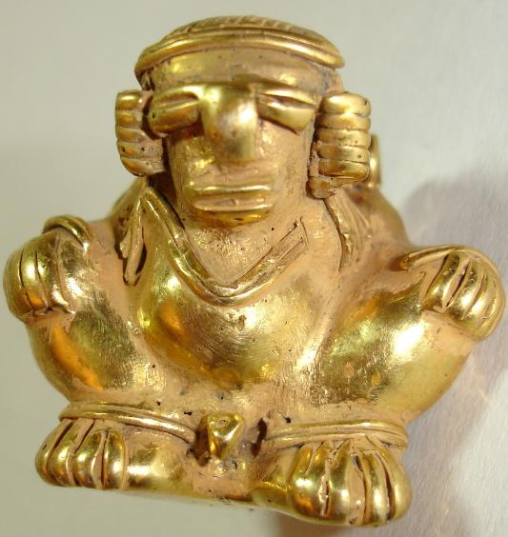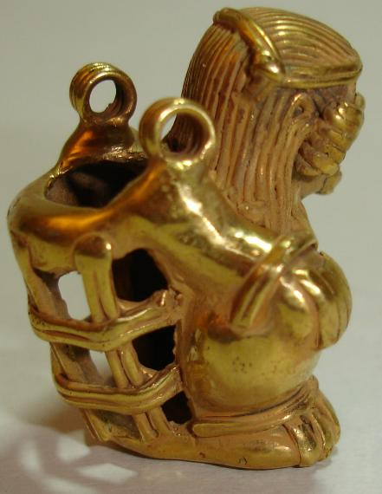

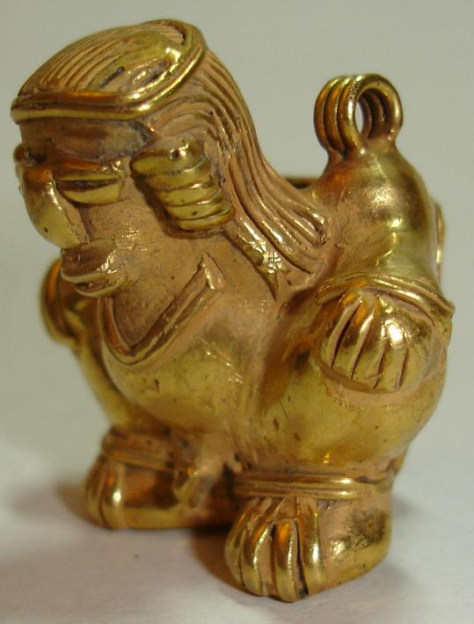 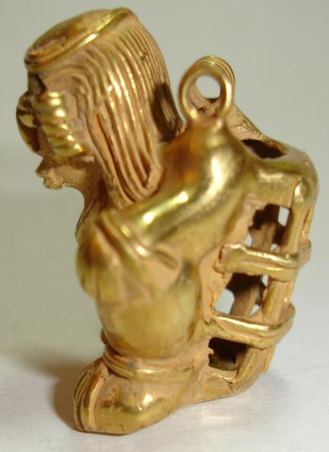

Figs. 1-4. Colombia-Tairona-Tumbaga-Basketman-1000-1500 CE

Case No.: 7

**Accession No.**

**Formal Label:**

**Display Description:**

**LC Classification:**

**Date or Time Horizon:**

**Geographical Area:**

**Map:**

**GPS coordinates:**

**Cultural Affiliation:**

**Media:**

**Dimensions:** 33 mm x 33

**Weight:** 21 grams

**Condition:**

**Provenance:**

**Discussion:**

**References:**